Processing 360 Panos for the Web
Prerequisites:
- Download and install KrPano software
Krpano Upload Process:
Individual 360 Photos:
- Download and rename the photo to include the location name - all lowercase with dashes instead of spaces. Don’t include campus reference in the filename. (i.e. earle-hall)
- Open Krpano Tools drag the file to the "MAKE PANO (NORMAL) droplet"
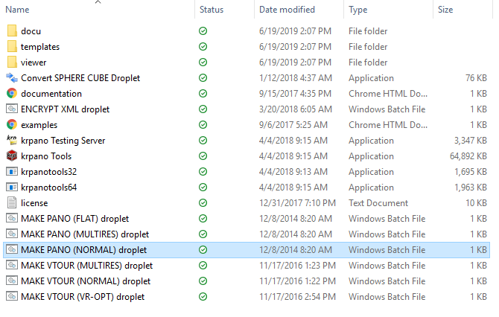
- Follow the onscreen prompts to process the files.
- The finished KRPANO files will be added to the original file folder
- Open the "index.html" file and edit the <title> tag to remove the "Krpano -" intro and update the title text to reflect how you want it to display in the browser tab. (This typically includes capitalizing the location name and removing the dashes").
- BEFORE:
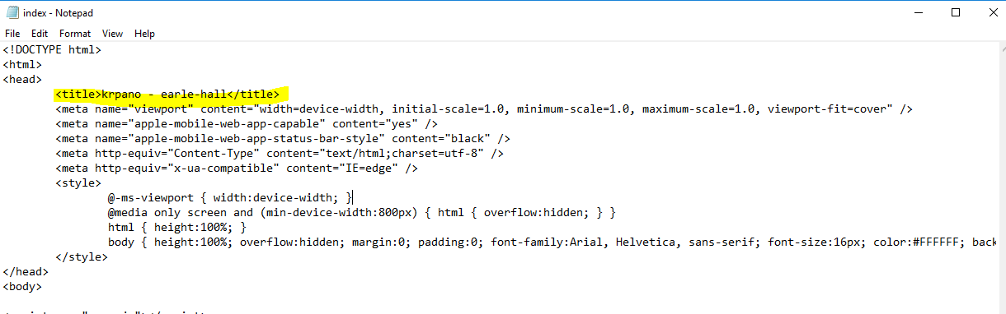
- AFTER:
- 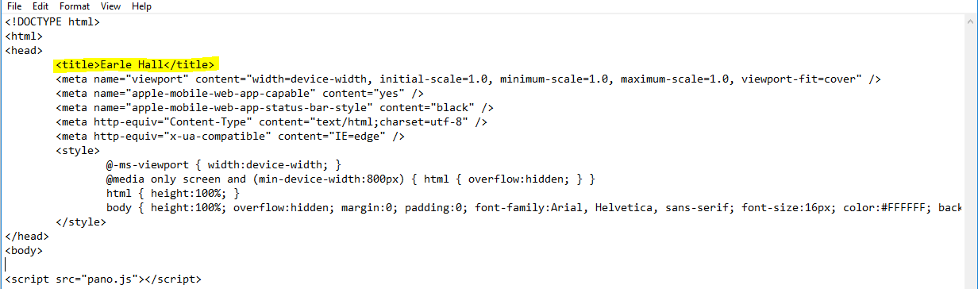
- Save the “index.html” file
- Remove “tour_testingserver_macos” and “tour_testingserver.exe” files from the new folder
- Prepare to create a zipped version of the folder.
  - Create a new folder titled with campus-name on your desktop (lowercase no spaces, use hyphens for locations with more than one word names)
  - Copy/move the Krpano 360 image folder to the new campus folder
  - Create a zipped folder from the campus directory folder (right click --> send to --> “compressed zip folder”)
    - Note: If you are adding more than one individual 360 image or virtual tour at the same time, complete the process for each image/tour and add all the folders to the campus folder before converting to a zipped folder.
- Upload the zipped folder to the site: https://liveon.prod.fbweb.psu.edu/admin/config/media/pack-upload
  - Click “Upload Bulk Media”
  - Select “Choose File”
  - Navigate to the zipped folder on your desktop and select
  - Click “Submit”
  - You should receive a message confirming a successful upload or error.

Virtual Tours:
- Download and rename the photos to include the location name/description using numbers to order the photos in the correct sequence for the tour - all lowercase with dashes instead of spaces (i.e. 1-east-halls- double-room, 2-east-halls-triple-room, 3-east-halls-supplemental-room). Note: The Krpano tool will place the images in the order in which they are named and this can’t be rearranged once the images are processed.
- Open Krpano Tools drag the files to the "MAKE VTOUR (NORMAL) droplet"
- 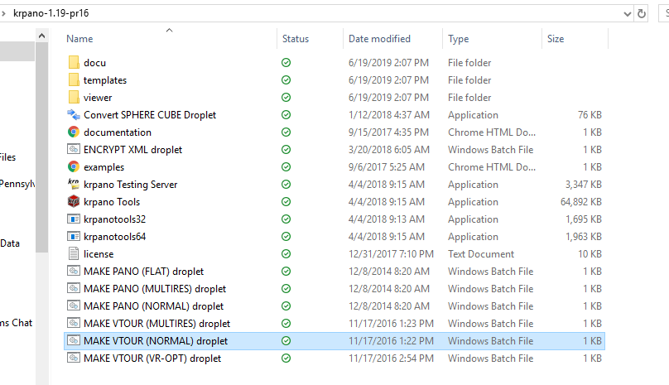
- Follow the onscreen prompts to process the files.
- The finished KRPANO files will be added to the original image file folder
- Open the "index.html" file and edit the <title> tag to remove the "Krpano -" intro and update the title text to reflect how you want it to display in the browser tab. (This typically includes capitalizing the location name and removing the dashes").
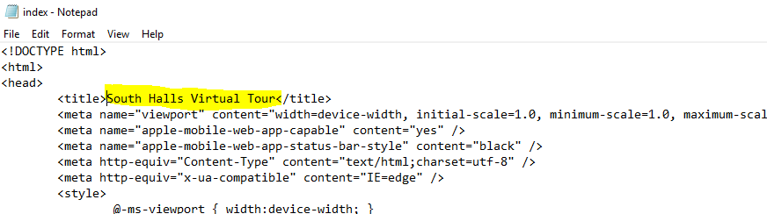
- Open the tour.xml file and make the following changes:
- Update title text to reflect how you want it to display within the tour experience. (This typically includes capitalizing the location name and removing the dashes).

- Set the configuration for Thumbs Opened to True. thumbs_opened=“true”
- Set the configuration for Thumbs Text to True. thumbs_text=”true”
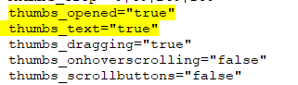
- Scroll down until you see the <scene name> tags and edit the individual image titles for each photo in the tour to reflect how you want it to display in the tour experience. (This typically includes capitalizing the location name and removing the dashes).
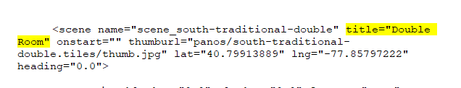
- Save the tour.xml file.
- Remove “tour_testingserver_macos” and “tour_testingserver.exe” files from the new folder
- Prepare to create a zipped version of the folder.
  - Create a new folder titled with campus-name on your desktop (lowercase no spaces, use hyphens for locations with more than one word names)
  - Copy/move the Krpano 360 tour folder to the new campus folder
  - Create a zipped folder from the campus directory folder (right click --> send to --> “compressed zip folder”)
    - Note: If you are adding more than one virtual tour our individual 360 at the same time, complete the process for each image/tour and add all the folders to the campus folder before converting to a zipped folder.
- Upload the zipped folder to the site: https://liveon.prod.fbweb.psu.edu/admin/config/media/pack-upload
  - Click “Upload Bulk Media”
  - Select “Choose File”
  - Navigate to the zipped folder on your desktop and select
  - Click “Submit”
  - You should receive a message confirming a successful upload or error.

Viewing your 360s:
- Once you’ve successfully completed the upload process the 360 files can be viewed using the following path structure: https://liveon.psu.edu/sites/liveon/files/panoramics/campus-name/location-name/
- Note: The campus name and location name will match the folder naming conventions from your zipped folders. For example: https://liveon.psu.edu/sites/liveon/files/panoramics/university-park/earle-hall/
- To place your 360s, create a section on the appropriate location page and add the preferred block (most use Call to Action). Copy and paste the correct location specific URL into the link field.

